УО «Белорусский государственный университет информатики и радиоэлектроники»

Кафедра ПОИТ

Отчет по лабораторной работе № 1

по предмету «Теория информации»

Вариант 5

Выполнил:

Дедов Н.Ю.

гр. 251003

Проверил:

Болтак С.В.

Минск 2024

**СТОЛБЦОВЫЙ МЕТОД УЛУЧШЕННЫЙ**

Тесты

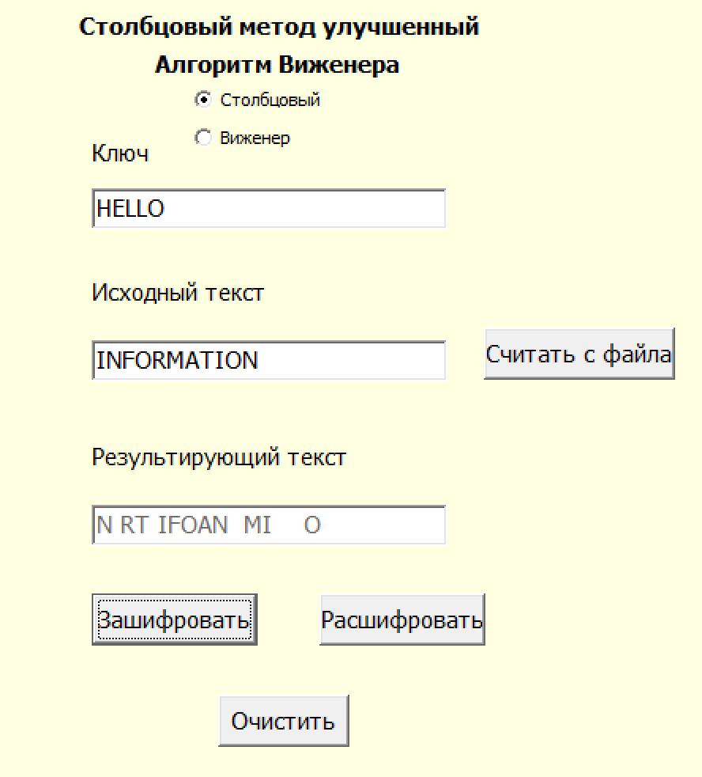 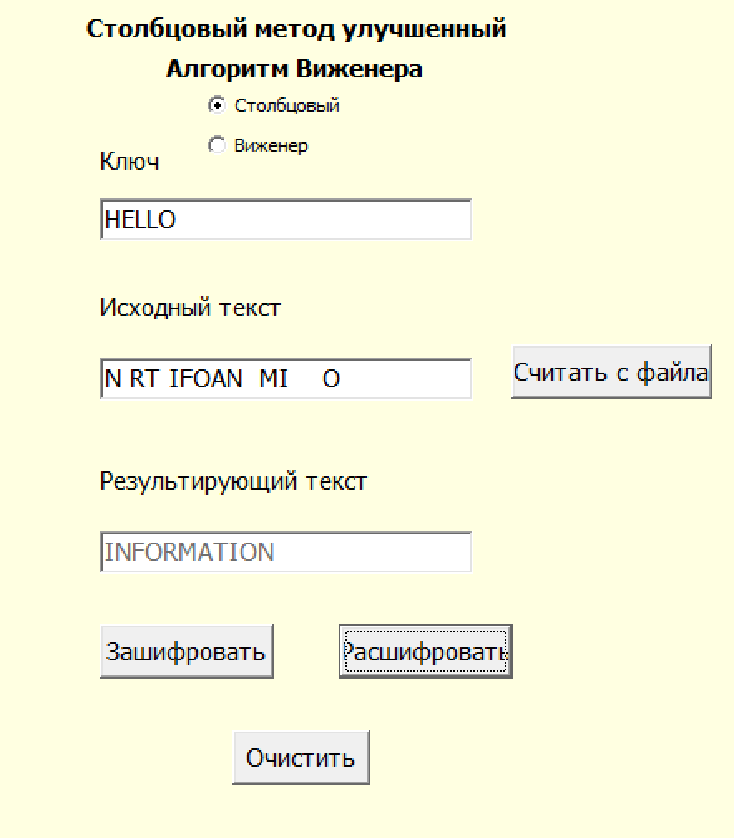

|  |  |  |  |  |
| --- | --- | --- | --- | --- |
| **H** | **E** | **L** | **L** | **0** |
| 2 | 1 | 3 | 4 | 5 |
| **I** | **N** |  |  |  |
| **F** |  |  |  |  |
| **O** | **R** | **M** |  |  |
| **A** | **T** | **I** | **O** |  |
| **N** |  |  |  |  |

*Шифротекст:* **N RT IFOAN MI O**

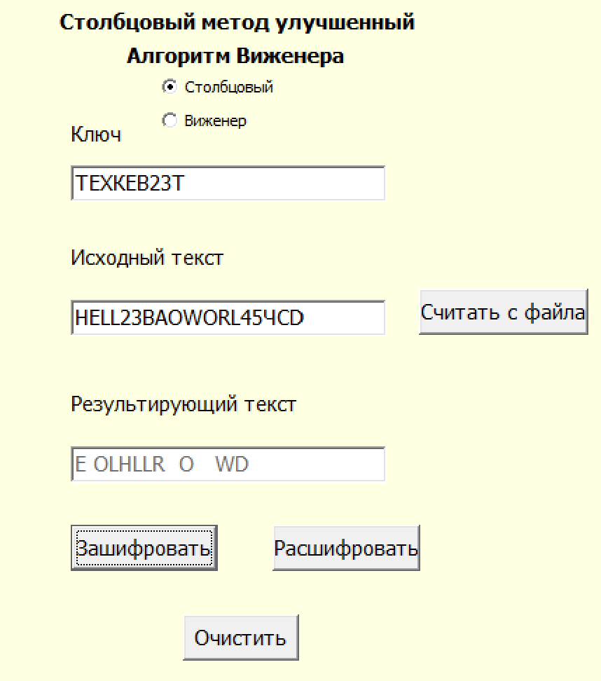 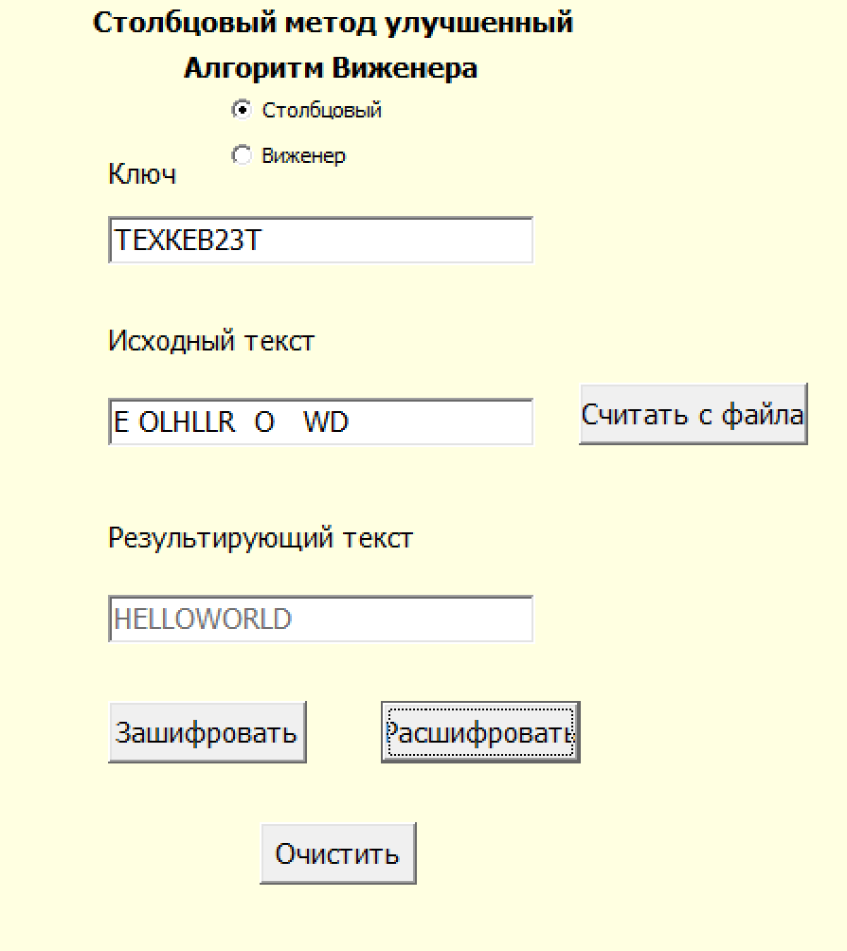

|  |  |  |  |
| --- | --- | --- | --- |
| **T** | **E** | **X** | **T** |
| 2 | 1 | 4 | 3 |
| **H** | **E** |  |  |
| **L** |  |  |  |
| **L** | **O** | **W** | **O** |
| **R** | **L** | **D** |  |

*Шифротекст:* **E OLHLLR O WD**

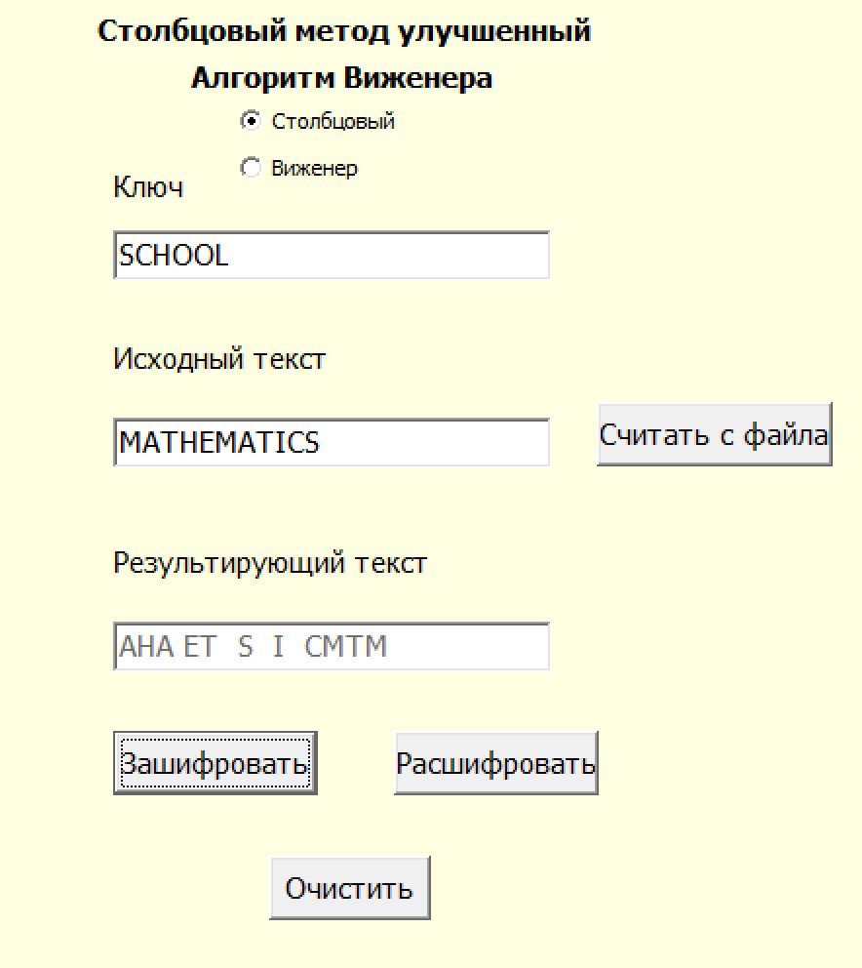 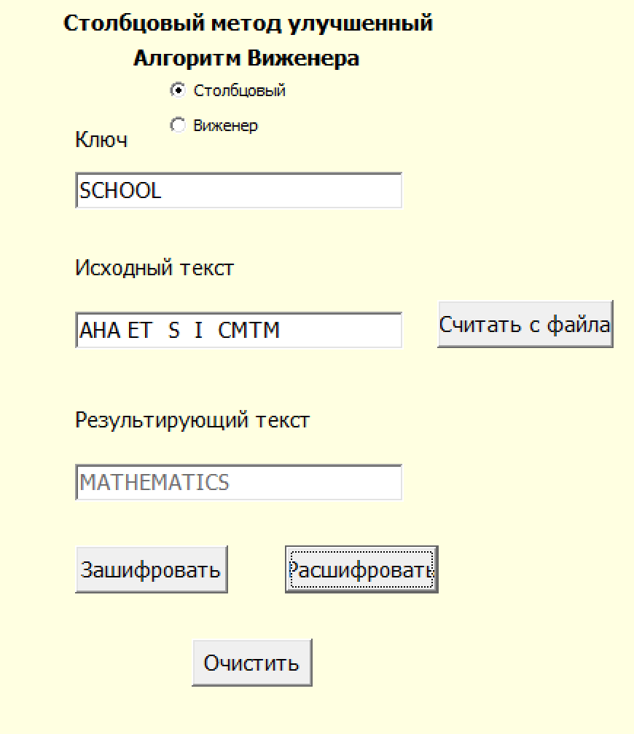

|  |  |  |  |  |  |
| --- | --- | --- | --- | --- | --- |
| **S** | **C** | **H** | **O** | **O** | **L** |
| 6 | 1 | 2 | 4 | 5 | 3 |
| **M** | **A** |  |  |  |  |
| **T** | **H** | **E** |  |  |  |
| **M** | **E** | **T** | **I** | **C** | **S** |

*Шифротекст:* **AHA ET S I CMTM**

**ШИФР ВИЖЕНЕРА С САМОГЕНЕРИРУЮЩИМСЯ КЛЮЧОМ**

Таблица Виженера для русского языка

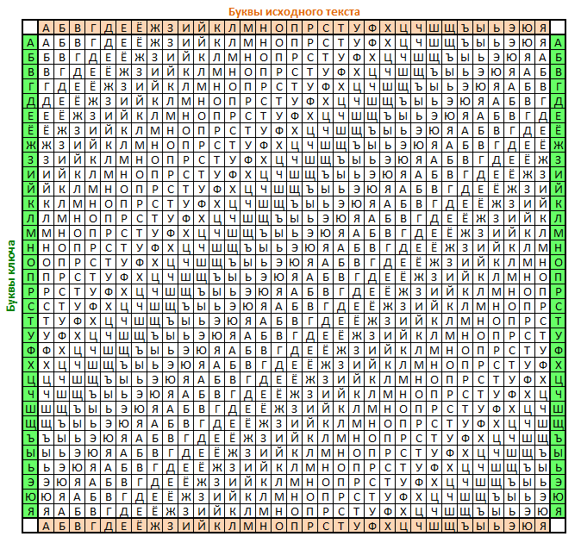

Тесты

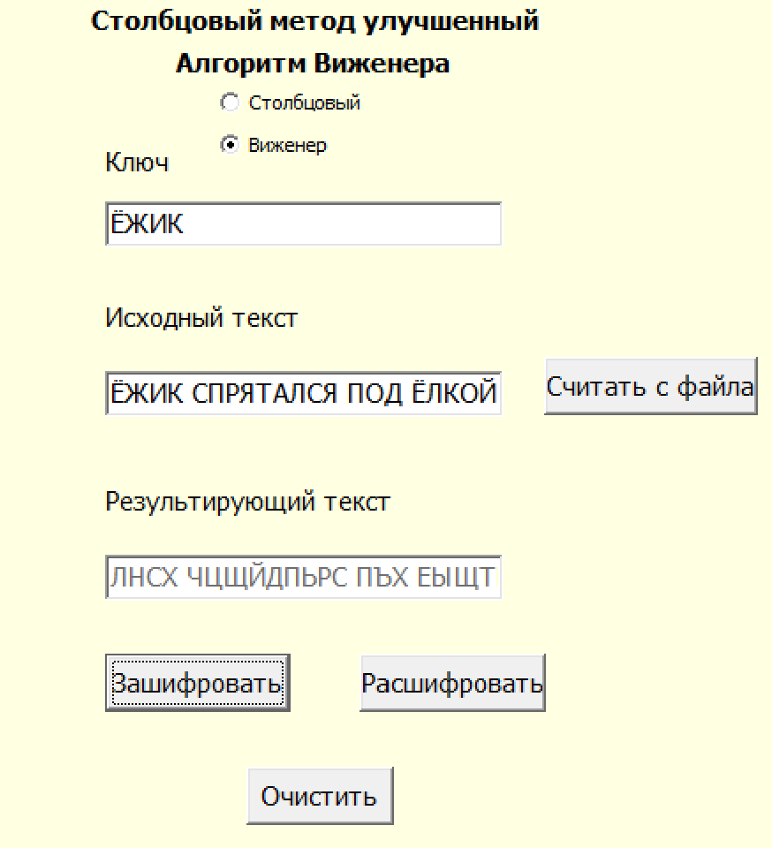 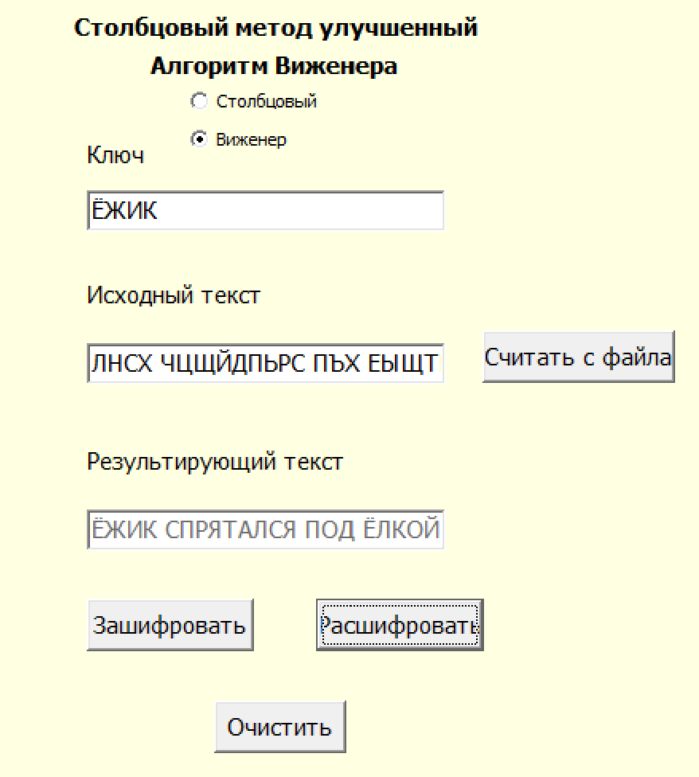

|  |  |  |  |  |  |  |  |  |  |  |  |  |  |  |  |  |  |  |  |  |  |  |  |
| --- | --- | --- | --- | --- | --- | --- | --- | --- | --- | --- | --- | --- | --- | --- | --- | --- | --- | --- | --- | --- | --- | --- | --- |
| **Ё** | **Ж** | **И** | **К** |  | **С** | **П** | **Р** | **Я** | **Т** | **А** | **Л** | **С** | **Я** |  | **П** | **О** | **Д** |  | **Ё** | **Л** | **К** | **О** | **Й** |
| **Ё** | **Ж** | **И** | **К** |  | **Ё** | **Ж** | **И** | **К** | **С** | **П** | **Р** | **Я** | **Т** |  | **А** | **Л** | **С** |  | **Я** | **П** | **О** | **Д** | **Ё** |

*Шифротекст:* **ЛНСХ ЧЦЩЙДПЬРС ПЪХ ЕЫЩТ**

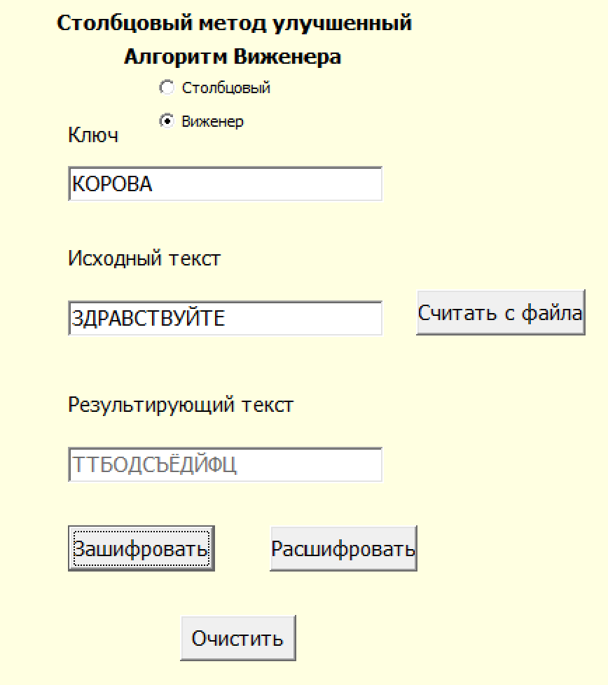 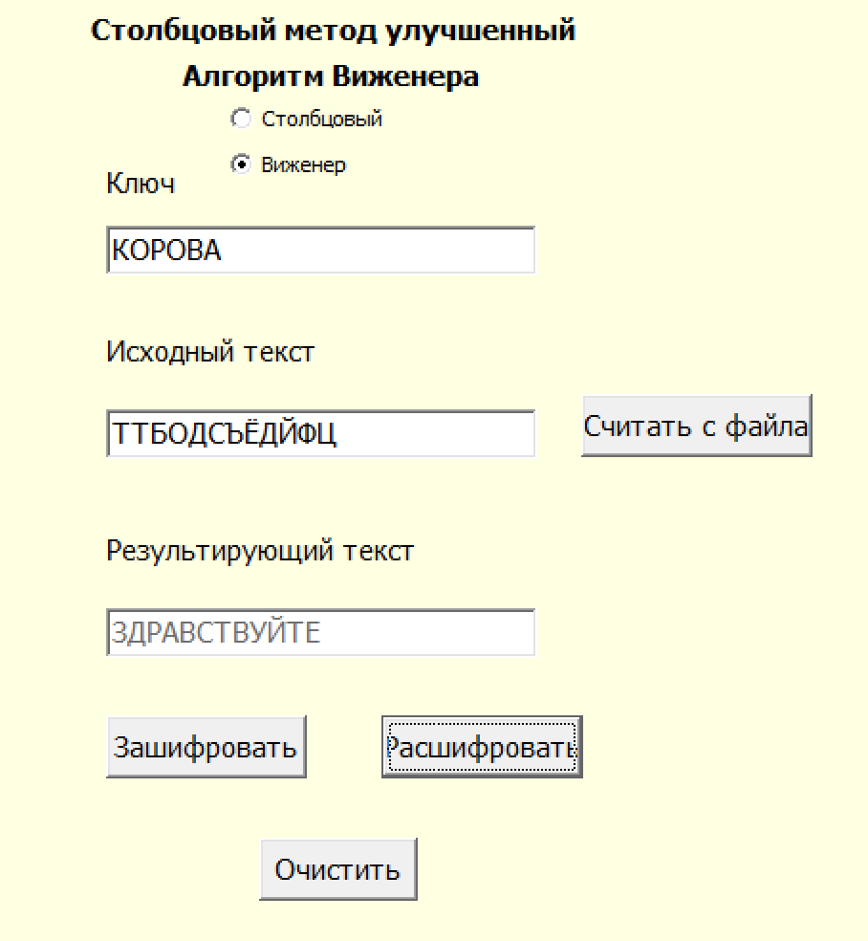

|  |  |  |  |  |  |  |  |  |  |  |  |
| --- | --- | --- | --- | --- | --- | --- | --- | --- | --- | --- | --- |
| **З** | **Д** | **Р** | **А** | **В** | **С** | **Т** | **В** | **У** | **Й** | **Т** | **Е** |
| **К** | **О** | **Р** | **О** | **В** | **А** | **З** | **Д** | **Р** | **А** | **В** | **С** |

*Шифротекст:* **ТТБОДСЪЁДЙФЦ**

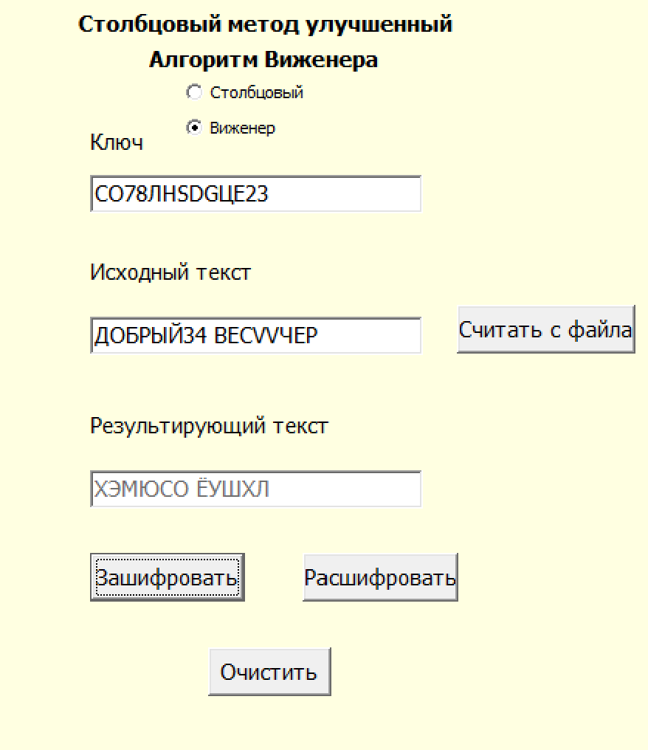 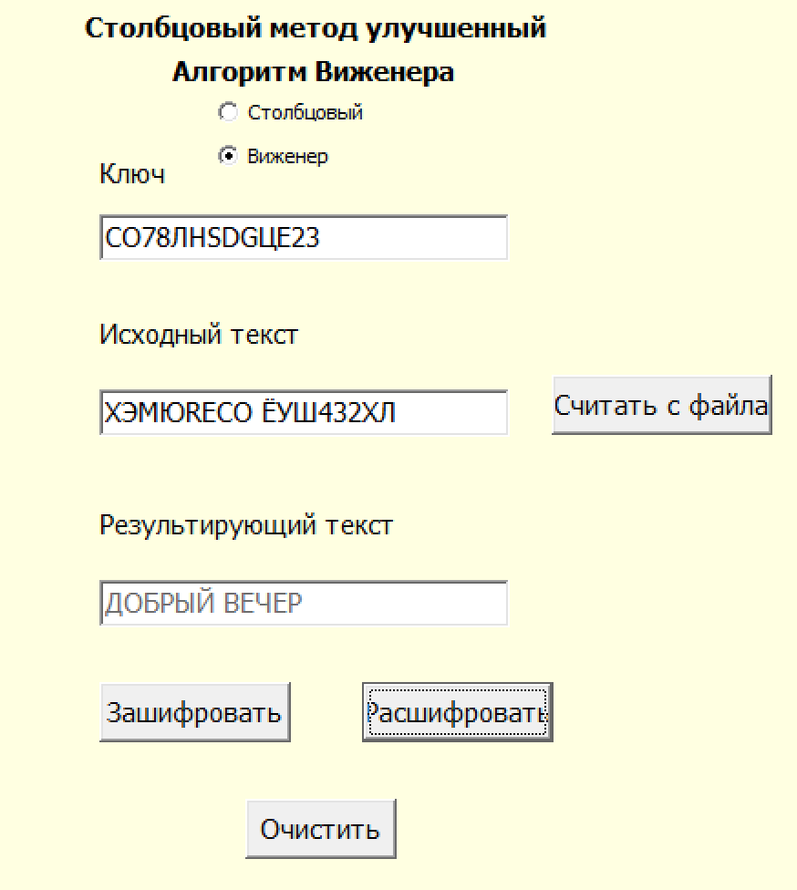

|  |  |  |  |  |  |  |  |  |  |  |  |
| --- | --- | --- | --- | --- | --- | --- | --- | --- | --- | --- | --- |
| **Д** | **О** | **Б** | **Р** | **Ы** | **Й** |  | **В** | **Е** | **Ч** | **Е** | **Р** |
| **С** | **О** | **Л** | **Н** | **Ц** | **Е** |  | **Д** | **О** | **Б** | **Р** | **Ы** |

*Шифротекст:* **ХЭМЮСО ЁУШХЛ**